1. Project Introduction and Description
   1. Project Aim: Data Analysis for Knowledge Extraction
   2. Goals
2. Background
   1. The Heart
      1. Sinoatrial Node and Arrythmias
   2. The Electrocardiogram
   3. A Heart Beat and the PQRST Sequence
   4. Current Methods for Detecting the PQRST Sequence
   5. Available Sensors
      1. Clinical vs Wearable
      2. Limitations of Electrocardiograms
3. Initial Design and Proof Of Concept
   1. Python
   2. Real-Time vs Pre-recorded Data
      1. Issues for Real-Time implementation
   3. UML Diagrams
   4. GitHub
   5. Scrum and Trello
4. Proposed Tasks
   1. Recording the Electrocardiogram
5. Implementation
   1. UML Diagrams
6. Testing
   1. TODO - N/A
7. Critical Evaluation
   1. TODO – Read this https://www2.southeastern.edu/Academics/Faculty/elejeune/critique.htm
8. Conclusion
   1. Aim of the Project
   2. Background and History
      1. Electrocardiograms
      2. Data analysis for knowledge extraction
9. Project Deliverables
10. Initial Annotated Bibliography
11. Appendix A – Third Party Code and Libraries
12. Appendix B – Ethics Submission

**Chapter 2  
Background**

This chapter addresses the related biological research which was necessary to undertake this project before explaining the process of converting a biological electrical signal into an electrocardiograph. The signal which is recovered is then explained before a brief outlook at the different devices capable of recording a signal and how the signal is normally broken down by a program.

**2.a The Heart**

The heart is a muscular organ which contains 4 chambers. These 4 chambers and additional valves allow blood to flow around the body unidirectionally. Muscles and tissue require the oxygen which is carried in the blood in order to create energy through a chemical process called aerobic respiration. To allow this process to happen, the heart “pumps oxygenated blood throughout the body and deoxygenated blood to the lungs” [1].   
If the heart is not functioning properly, the body may not be getting the optimum level of blood in order to sustain itself which could lead to a multitude of issues.

**2.a.i Sinoatrial Node and Arrhythmias**

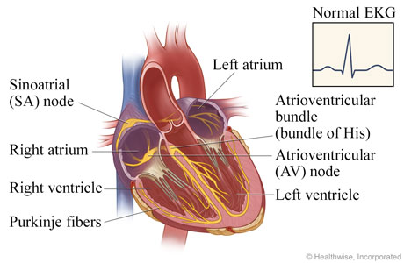The sinoatrial node (SA node) ensures that the heart beats in a regular rhythm to ensure optimum blood flow which is one of the reasons it is also known as the body’s natural pacemaker. This is done with an electrical signal which “spreads through the walls of the atria and causes them to contract” [2].  
  
**1.** The signal initially starts at the SA node (located in the right atrium) and propagates to the left and right atria. This in turn causes them to depolarize and pump blood into the ventricles below.  
  
**2.** The Atrioventricular node (AV node) acts as a gate which slows the signal, allowing the ventricles to fill with blood.  
  
**3.** The AV node forwards the signal across the ventricles causing them to depolarize which pumps blood around the body. Whilst this is happening, the atria re-polarize.

Figure – Cross Section of the Heart [3]

**4.** The ventricles finally re-polarize after all the blood has been pushed out of them. [3][4]

If the signal from either the SA node or the AV node is timed incorrectly, the heart can develop an arrhythmia. If the electrical activity of the heart is healthy, the rhythm will be diagnosed as a “normal sinus rhythm”. Sinus arrhythmia is directly related to an incorrect timing of the SA node [5].  
  
Atrial fibrillation (AFib) occurs when the SA node fires multiple signals causing a spasm in the atria making them less effective. This confuses the AV node which de-polarises the ventricles in an unorganised manner leading to an irregular heart beat[2].  
  
In certain circumstances, it may be necessary to fit a patient with an artificial pacemaker that replaces the SA node.

**2.b The Electrocardiogram**

An electrocardiograph is a device which has multiple electrodes which are placed on the skin. These sensors detect the electrical signals which are produced by the SA node and AV node. The signals transmit up a wire into a computer which attempts to filter out any biological noise that might happen during the reading.   
  
The readings that the electrocardiograph takes are displayed as an electrocardiogram (ECG). ECG’s are commonly displayed as a 2-dimensional line graph with the x-axis resembling time and the y-axis resembling amplitude in millivolts (mV).  
  
There are multiple electrocardiographs on the market and each device allows for a different function. Certain electrocardiographs have been developed to remove as much signal noise as possible because a long-term study may need to be conducted on a mobile patient outside of a hospital. These machines are called Holter monitors.   
Clinical electrocardiographs such as the one which was used in this project utilize 12 leads with 10 electrodes and typically take readings for a 10 second period. Different filters can be implemented when setting up the recording software dependant on the study.

**2.c A Heart Beat and the PQRST Sequence**

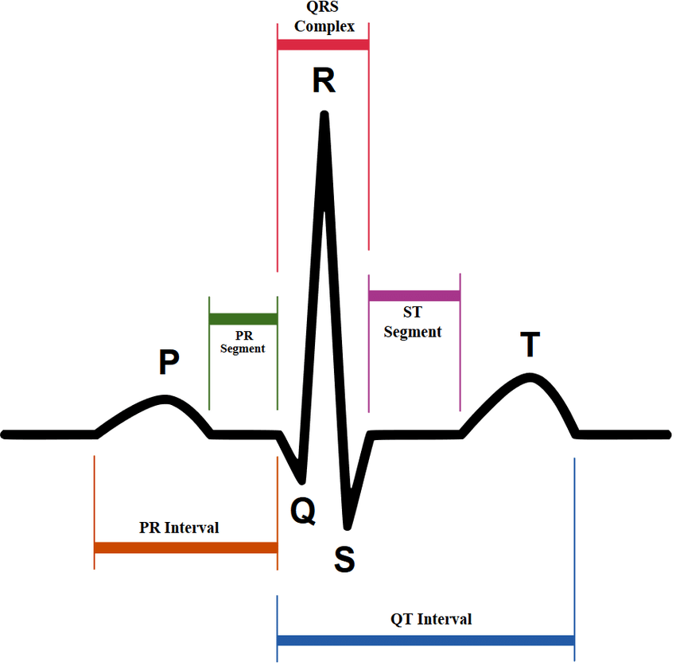After an ECG has been recorded using an electrocardiograph, singular beats can be broken down into their corresponding PQRST sections. These sections are easily characterizable by a medically trained professional if a high-quality signal has been recorded.  
Utilizing the points from 2.a.i:

1. The P wave is associated with point 1 – The left and right atria depolarising and pumping blood into the ventricles.
2. The Q wave relates to point 3 and early ventricular depolarisation.
3. The R wave relates to point 3 and the main ventricular depolarisation. The reason for its height (as seen in figure 2) is due to the larger size of the ventricles compared to the atria.
4. The S wave relates to point 3 and the depolarisation of the Purkinje fibres.
5. The T wave relates to point 4 and the repolarisation of the ventricles. [4]

Figure - PQRST Sequence [6]

Noise can be an issue when recording using an electrocardiograph and this can lead to three common issues:  
  
Baseline wander can be distinguished by seeing the overall signal change its amplitude over time causing a wave. This can make it difficult to distinguish certain parts of the PQRST sequence. It is often caused by body movements due to respiration but can also be caused by perspiration. Baseline wander was an issue in this study for my personal readings due to the perspiration from the stress of a clinical setting. Because of the biological nature of this issue, filtering is needed post recording [7][8].  
  
Power line interference is caused by an electromagnetic field that occurs in the powerlines which run from the electrodes to the electrocardiograph. This can add 60 Hz frequencies into the ECG making it hard to distinguish certain sections such as the P and T waves which have low amplitudes. Shielded electrode leads and keeping leads apart can help to stop the frequencies, but they can still commonly occur [7][8].

Electromyographic noise occurs due to electrical stimulation within the muscles where the electrodes are placed that can add interference. The noise can manifest as small changes of amplitude across the signal or inverted P, R and T waves. This can be filtered out in part by the electrocardiograph dependant on the model, however the noise can be reduced by using post filtering [7][8].

**2.d Current Methods for Detecting the PQRST Sequence**

[1] Inc Argosy Publishing. At the Heart of It All: Anatomy and Function of the Heart.  
<https://www.visiblebody.com/learn/circulatory/circulatory-the-heart>, 2008.  
Text: Direct Quote.  
Accessed April 2019.   
  
*A webpage as part of a broader website by Argosy Publishing that is used as a 3D human anatomy visualisation and learning tool. This webpage allows for a detailed look at the structure of the heart and gives a thorough breakdown of how the heart works.*

[2] Cleveland Clinic. Heart Beat.  
<https://my.clevelandclinic.org/health/articles/17064-heart-beat>, 2018.  
Text: Direct Quote regarding SA node.  
<https://my.clevelandclinic.org/health/diseases/16765-atrial-fibrillation-afib>, 2019  
Text: Research regarding Atrial Fibrillation  
Accessed March 2019.  
  
*A webpage operated by an American academic medical centre that is based in Cleveland, Ohio. The webpage discusses the heart’s electrical system and the normal electrical activity that is provided via the SA node in order to allow for blood to pump to and from the heart.*

[3] My Health, AV node ablation for atrial fibrillation.  
<https://myhealth.alberta.ca/Health/pages/conditions.aspx?hwid=zm6205>, 2018  
Image: Cross section of the heart.  
Text: Used for research.  
Accessed March 2019.  
  
*A website operated by the Alberta government and Alberta health services to allow for access to health related information. Used as research to illustrate how the SA node and AV node work.*

[4] AliveCor, What is an ECG?  
<https://www.alivecor.com/education/ecg.html>, Unknown  
Text: Used for research in regards to the SA node, AV node and the PQRST Sequence.  
Accessed March 2019.  
  
*A webpage ran by AliveCor which is a medical device/Artificial Intelligence company which sells ECG hardware. Used for research detailing how the SA node and AV node work inside of the heart.*

[5] Medical News Today, Sinus arrhythmia: Definition, signs and diagnosis  
<https://www.medicalnewstoday.com/articles/319987.php>, 2017  
Text: Used for research  
Accessed March 2019.  
  
*A webpage ran by Medical News Today – a news outlet that reports the latest medical news. Used to research and support the link between Sinus Arrythmia and the SA node.*

[6] Ramos, Guilherme & Alfaras, Miquel & Gamboa, Hugo. (2018), Real-Time Approach to HRV Analysis  
Available from: <https://www.researchgate.net/figure/ECG-PQRST-points_fig1_322879235>, 2018  
Image: PQRST Sequence as shown as an ECG.  
Accessed April 2019.  
  
*A paper that was written which can be found on the link above. The image has been used for illustration and the image contained in this paper is widely known to be correct.*

[7] Author: N/a. University of Washington, ECG Filtering.  
Available from: <https://courses.cs.washington.edu/courses/cse466/13au/pdfs/lectures/ECG%20filtering.pdf>, 2013.  
Text: Used for research regarding Baseline Wander, Power Line Interference and Muscle Noise.  
Accessed March 2019.  
  
*A lecture that is from the University of Washington. This source does not have a lecturer’s name assigned to it. It can be deemed reputable considering that it is on the University of Washington’s website. Additionally, there is another reference [8] that collaborates the findings in this lecture. This lecture talks about different methods to filter ECG signals*

[8] Cecilia Vinzio Maggio, Ana & Bonomini, María & Laciar, Eric & Arini, Pedro. (2012), Quantification of Ventricular Repolarization Dispersion Using Digital Processing of the Surface ECG.  
Available from: <https://www.researchgate.net/publication/221923119_Quantification_of_Ventricular_Repolarization_Dispersion_Using_Digital_Processing_of_the_Surface_ECG>, 2012.  
Text: Used for research to collaborate findings with reference [7] about Baseline Wander, Power Line Interference and Electromyographic Noise.  
Accessed March 2019.  
  
*A study conducted to quantify the QRS Complex by processing an ECG. This study discusses the changes that are needed to be made to raw data in order to extract information.*